IMMC 2022 Autumn—Problem C
Team Control Number: IMMC22513686

I. Summary
It is fact that the pandemic has brought about significant changes to the world. With the people scared of becoming a potential victim to covid, many tend to stay at home and simply segregate themselves from the outside. Therefore, this situation has brought about some interesting topics that are worthy of discussion. For instance, a notable fact is the drop in influenza, where the number of case reports decreased from 27,500 in 2019 to 12,500 in 2020 with the sudden arrival of pandemic between those two time periods. As we can see, the pandemic is a vital factor in impacting the number of people being infected by the virus. As a result, we decided to analyze the influenza statistics in year 2019 and 2020 in order to compare the data to get the risks and possible challenges that this disease may create after the pandemic has ended.
When we started the project, we thought about the two main risks when considering the problem which could potentially let the case reports for influenza to increase: the lessening number of vaccines produced for influenza and the decreasing number of people who are inclined to go to the hospital for treatment when they start to bear symptoms of influenza. In addition, we also identified the main challenge when the pandemic lessens as the number of vaccines needed to completely solve the virus. During the process, we also came to the conclusion that the number of people being infected by the virus could be affected by multiple factors, so we categorized them.
Essentially, the principal algorithm that we formulated included a total of 5 variables: the total number of people, the number of people who receive the vaccine, the initial number of susceptible civilians, the number of people who have recovered from the virus, and also the number of people who are currently situated in incubation period. For each variable, it includes several numbers between differing time periods which can furthermore provide a direct comparison between how covid has affected the statistics of influenza case reports.
A feature of the algorithm is that it includes all the crucial factors so that the equation is overall more comprehensive and can put the factors into reflection. By doing so, it means that our algorithm is clear, concise, and is most importantly, accurate in its results.

Contents
II. Introduction 3
III. Defining the problem 3
3.1 Question restatement 3
3.2 Assumptions 4
3.3 Variables 4
IV. About the Algorithm 5
4.1 Overview 5
4.2 Constructing a S.I.R.E. Model Simulation for Influenza 5
4.3 Researching and Analyzing Data 6
4.4 Risk 6
4.5 Challenges 8
4.6 Summary 9
V. Strengths 10
VI. Weaknesses 10
VII. Conclusion 10
VIII. Appendix 11

II. Introduction
The incidence of this year's flu season is significantly lower than in previous years. The COVID-19 pandemic has lasted for nearly two years. Non-pharmaceutical interventions (NPIs), such as wearing facial mask, using hand sanitizer, social distancing, travel restriction, contact tracing, mass testing, targeted quarantine, etc., have been demonstrated to be effective in containing the pandemic as well as reducing the risk of other notifiable infectious diseases (NIDs). [8]
Before explaining the problem, we will begin first by defining what the problem is requiring.

III. Defining the problem

3.1 Question restatement

This question requires us to:
1. Use real-world data and appropriate mathematical models to characterize and analyze the risk and challenges of future outbreaks of a notifiable infectious disease other than Covid-19.
2. Select one Chinese province or city for our study.
In this paper we will talk about influenza effects in Shanghai. [2]
Given these objectives, we can begin laying out the assumptions and variables we need to account for and define.

3.2 Assumptions

In designing our model, we decided on several basic assumptions. Listed below are the assumptions and our justifications for them.

Assumption | Justification
The number of people after covid will maintain at a number of 27,796,000 in Shanghai | It is impossible to calculate the accurate number of people in Shanghai at each moment, and by doing so we can be also rid of unimportant factors affecting the Shanghai population which can also make our calculations easier.
All the people in Shanghai will take off their masks after the pandemic regardless of their state of well-being. | If we do not make this assumption, there will always exist some people who will wear masks, possibly because they may have a cold and want to provide a layer of protection. However, we cannot calculate the probability for how many people will be sick after the pandemic, so by making this assumption the algorithm can be made more realistic and negotiable.
The number of people who are vaccinated will be entirely immune to influenza, and the people who haven’t would be fully vulnerable to the virus. | There are limitless factors that can affect a person’s immune system, and so by making this assumption, the problem is made clearer to comprehend.
The population will only be affected by influenza. | The population is only an estimate, and other factors that may potentially affect the population won't create a significant change in the number.

3.3 Variables
Variable | Definition
S₀ | Initial number of people susceptible
E₀ | Initial number of people exposed to the influenza (who are not able to spread the influenza)
I₀ | Initial number of people infected
R₀ | Initial number of people recovered, died, or immune
P | Total population
Te | Length of Incubation Period
$$β$$ | Coefficient of susceptible being infected by infected people
$$Γ$$ | Coefficient of people recover or die

IV. About the Algorithm

4.1 Overview
Our algorithm includes two major components: the predicament of risk and challenges of the influenza in the future. We categorize the analyzation of risk into two parts of different magnitudes based on whether there is a mutation of the virus or not. There is a major change in result, for vaccine does not work if mutations occur. In order to help conclude an outcome, we utilize the S.I.R.E. model to compare differences in results due to factors such as whether people wear masks or not. The analyzation of the challenge is based on logical reasoning and educated guesses based on knowledge of pandemic, search information et cetera. Some main problems are how to stop the influenza and treatment during the pandemic.

4.2 Constructing a S.I.R.E. Model Simulation for Influenza
[3]
With given β and γ, we want to calculate the number susceptible, infected, recovered, and exposed. Though it is challenging to evaluate the exact result at a certain point of time, we are able to predict the number of S.I.R.E. with the previous data of S.I.R.E., like recursion. With that in mind, we come up a formula of S(t) to find the number of susceptible over a time period of t.
Suppose there are 100 people as total population, 60 infected, 40 susceptible, and β = 1 per day, for the next day, 40 / 100 = 40% (or $\frac{S\left(t\right)}{P}$) of people are susceptible. Therefore, $60×1×40\%=24$ people will be exposed the next day, and the change of S(t) is -24.
$$S\left(t\right)= -β×I'\left(t\right)×\frac{S'(t)}{P}$$
Next, to find the pattern of number of infected and cured, we estimate that the infected equals $\frac{E\left(t\right)}{Te}$ because the infected always start as exposed, but considering the people that are recovered, the final formula is revised below.
$$I\left(t\right)= \frac{E'\left(t\right)}{Te}- γ×I'(t)$$
Similarly, if 60 people are infected, and γ = 1/3, the number of people cured is $60×\frac{1}{3}=20.$
$$R\left(t\right)=γ× I'\left(t\right)$$
The number of exposed is the number of people exposed ($β×I'\left(t\right)×\frac{S'(t)}{P}$) subtracted by the number of people who have just became infected.
$$E\left(t\right)=β×I^{'\left(t\right)}×\frac{S^{'}\left(t\right)}{P}-\frac{E'\left(t\right)}{Te}$$
At the end, we have four differential equations, yet our goal is not to solve the functions, but to help graph a simulation for Influenza. With Python implementation, the visualization of the change of S.I.R.E is presented.

4.3 Researching and Analyzing Data
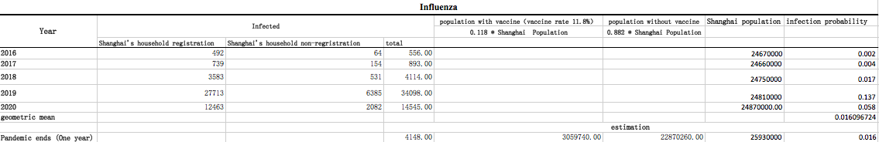
Most of the data we employ in the algorithm are based on Shanghai governmental websites to ensure authenticity. [6], [7],[9]

Geometric mean is calculated for sections where we estimate values for infection probability to ignore the effects that outliers can bring to the outcome. The initial number of influenza-infectious (I₀) people after COVID-19 is evaluated by $Shanghai^{'}s population×$ infection probability. With S₀, I₀, and R₀ (people who took vaccines), we are capable to construct S.I.R.E. models to delineate the risk.

4.4 Risk
About Mutation
Essentially, influenza either mutates by antigenic shift or antigenic drift [1].
Antigenic shifts are gradual transformation of a virus’ genetic material, which are general influenced by humans’ immune system and point mutation, a mutation where one nucleotide base is altered, switched, inserted, or sequence of influenza’s genome, in a virus’ gene. Antigenic shifts are also the reason why a person can catch influenza multiple times in their lives. As a result, vaccines are required to update annually in order to keep up the pace of antigenic shifts.
Antigenic drifts are short and abrupt transformations that can rearrange influenza’s assortment of genome which determines the chemical make-up of proteins in the virus’ outercoat of antibody. Compared to antigenic shifts, antigenic drifts are less likely, for myriad events must fall into place. However, people’s immune system is entirely vulnerable to virus that been through antigenic drifts and vaccines do not work on them since humans’ immune systems do not recognize the new type of virus.
In conclusion, mutations of influenza are consistent and unpredictable basing on the development of environment, yet mutation is critical to our model because the results differ considerably. Therefore, we include both cases where influenza does mutate and does not mutate.
With Mutation
If influenza virus mutates, it signifies that everyone has the capability of being infected, including the ones that are vaccinated, and we have the data below.
$$S_{0}=25930000-4148=25925852$$
$$I_{0}=4148$$
$$R_{0}=E_{0}= 0$$
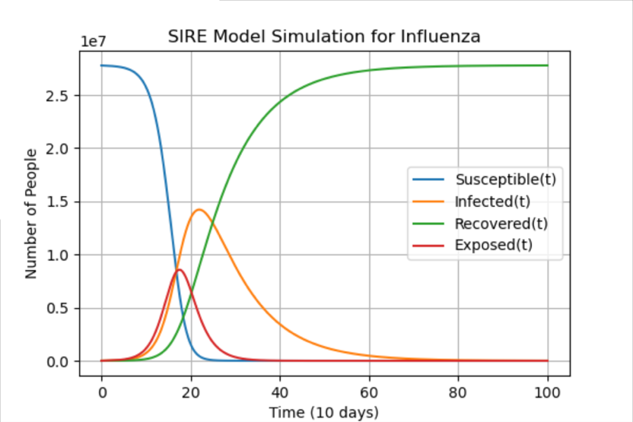
Plugging in the variables into the program, we can obtain the following S.I.R.E. graph.
With No Mutation
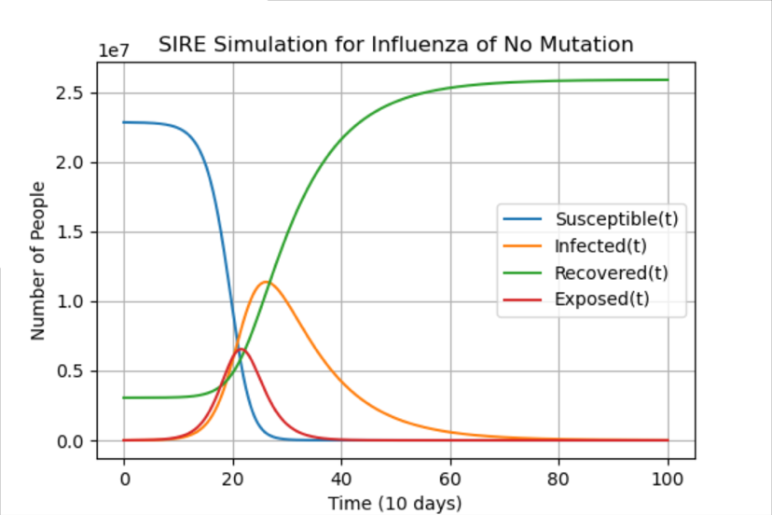
If influenza virus does not mutate, we assume that people who are vaccinated are completely immune and will not be affected and carry the virus.
$$S_{0}=22871112$$
Figure 1: SIRE if Mutation
$$I_{0}=4148$$
$R_{0}= 3059740$ (vaccinated)
$E_{0}=0$
It is obvious to tell that mutation accelerates the process in which influenza spreads, as the maximum number of people infected increases.
Figure 2: SIRE of No Mutation

In figure 2, the maximum of infected is when 262 days after when epidemic prevention measures are all removed, tallying up a number of 11391144 people infected. Whereas in figure 1, the maximum of infected is after 225 days, enumerating a number of 13271711 people, with a difference of 2000000 people.
However, preventions of the outbreak of influenza are not included in the graphs, such as situating quarantine areas and wearing masks. In the graph below, we simulate a scenario when people all wear masks, which reduces β, an infector’s ability to spread the virus, by 70%.
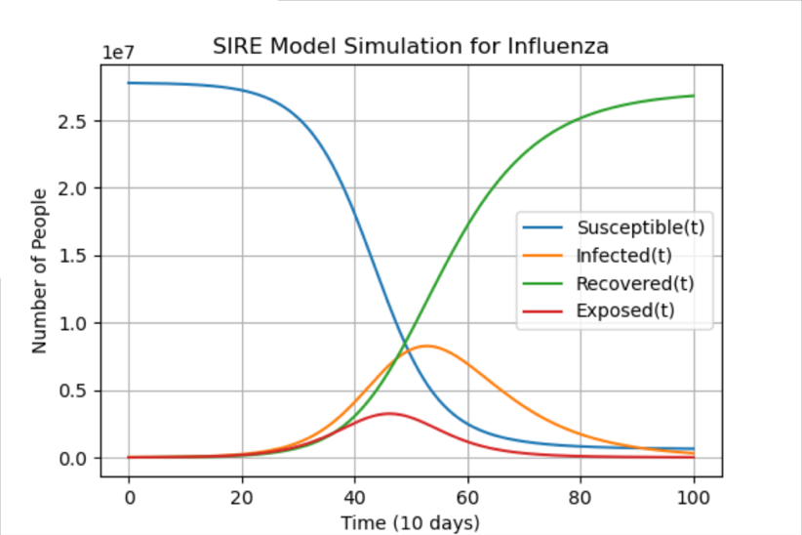
Inferring from the evidence, factors that restrict coefficient β can elongate influenza activity as well as decreasing the number of infected.
To summarize, influenza with mutation is more threatening than no mutation because more people are susceptible when confronting the spread of influenza. However, by cautious prevention measures, risks can reduce in a substantial degree.
Figure 3: SIRE with Mutation and Masks

4.5 Challenges

After a pandemic outbreak of influenza, many problems will occur. Some obvious problems are stated below.
1. Vaccine Creation
More vaccines will be needed to control the outbreak. To totally end this outbreak, 54.6% immunization rate is needed. Taking this to Shanghai, 14 million vaccines will be needed to actually stop the virus. To make problems even worse, a vaccine also has a 20% scarp rate. In all, around 17 million creation of the vaccine is needed. This is a huge number and will need many materials and money to create. This will result in both a noticeable decrease in the economy and also in the supply of medical materials.
2. Treatment of Patients
People infected with influenza will go to hospital for healing. In a pandemic, there will possibly be a shortage of hospital needs, as it has already spread its resources all around in every place like before. In addition, people may also be less encouraged to go to the hospital to receive treatment due to possible fear of becoming a victim of covid. The hospitals need to turn its resources at influenza to solve the problem first. This will be similar to the COVID-19 pandemic.
3. Productivity Loss
After an outbreak, there will always be a quarantine time period that prevents anyone from going outside. However, many kinds of work are need the workers to go outside and cooperate with each other. In the quarantine period, it is impossible to be together and work. Although due to the COVID-19 pandemic, people are experienced with online work, productivity will still decrease since, after all, in real life, communication is much more convenient and direct while people need to send emails and arrange for specific periods of time to actually a discuss a problem online.
4. Death Rate
Influenza might not seem to have an outstanding death rate (1.8/100000 people). However, to those who are 65 years or above, the death rate can leap to 22.1 / 100000 people. There are around 7.8 million elders in Shanghai. Deaths from old people can increase to a large number.

4.6 Summary
In this algorithm, we used the SIRE model to monitor possible scenarios that would have appeared after the COVID-19 pandemic. There are two main cases, whether the influenza have mutated (where vaccines will have no use), or the influenza haven’t mutated (where vaccines are useful). These both leads to different consequences that add up to the risk. After the algorithm, it was clear that influenza doesn’t have a very high infection, but its mutation creates difficult problems to solve. With mutation, the infected number of people increased significantly. The risk is high enough to need many attentions from the government.
To analyze the challenge, we have considered problems that will happen in an influenza pandemic. We notify immediately vaccine creation, treatment of patients, productivity loss, and death rate of the old. These main problems together contrast the most urgent main problems that the pandemic have brought.

V. Strengths
5.1. Our algorithm put most of the important factors into consideration like whether there will be mutation for the virus and the different branches of the factors. By doing so, the results are guaranteed to be accurate and comprehensive when we take almost all things into account. The factors that are unmentioned in our model are either insignificant or do not contribute to the main factor.
5.2 The model created is flexible. Any inputted data will return corresponding results. This means that this model is not set in a certain style; it can be applied to other problems requiring the same type of result as well. Therefore, our model is useful in not only a limited number of ways, but can help people solve many problems.
5.3 We did an extensive amount of research in order to get several different sources of data so that we could compare them and choose the most credible one in order to build our algorithm in order to ensure that the data we use would not become a misleading factor that would damage the structure of the project.

VI. Weaknesses
6.1. The numbers and data are all originated from the previous years’ statistics. Therefore, this may serve as a problem in the level of accuracy that the statistics will prove to be in this problem since it is undeniable that there will be changes
6.2 Another weakness which we have realized when searching for data is that the numbers are not the precise amount, but rather a close estimate to the actual number, so our final result may be a relatively a little off from the real result.

VII. Conclusion
In conclusion, our team may have some weaknesses which can be improved, yet even if we may have data that is not precise enough, we make up for this flaw by considering many factors and also taking into account many other further branches of those factors in order to get more concise and accurate results. By doing so, our algorithm can be much more inclusive and not only be based upon the most fundamental of all components. Overall, our model is both effective and succinct in helping us find the results that we want.
The project required us to identify the risks and challenges that a non-covid NID, where we chose influenza, would bring to a specific Chinese city, where we chose Shanghai.
The challenges that we identified were:
- Vaccine creation
- Treatment of Patients
- Productivity Loss
- Death Rate

VIII. Appendix
8.1. Python Implementation
import scipy.integrate
import numpy as np
import matplotlib.pyplot as plt
# model
def model(y, t, beta, gamma):
S, I, R, E = y
dS_dt = -beta * S * I / P
dI_dt = E / Te - gamma * I
dR_dt = gamma * I
dE_dt = beta * S * I / P - E / Te
return ([dS_dt, dI_dt, dR_dt, dE_dt])
# initialization (varies in different scenarios)
P = None
S0 = None
I0 = None
R0 = None
E0 = None
Te = None
# coefficients
beta = None
gamma = None
# time vector
t = np.linspace(0, 100, 10000)
# result
res = scipy.integrate.odeint(model, [S0, I0, R0, E0], t, args=(beta, gamma))
res = np.array(res)
for i in range(4):
print(str(max(res[:, i])) + " at " + str(np.where(res[:, i] == np.max(res[:, i]))))
# plot
plt.figure(figsize=[6, 4])
plt.plot(t, res[:, 0], label='Susceptible(t)')
plt.plot(t, res[:, 1], label='Infected(t)')
plt.plot(t, res[:, 2], label='Recovered(t)')
plt.plot(t, res[:, 3], label='Exposed(t)')
plt.legend()
plt.grid()
plt.xlabel('Time (10 days)')
plt.ylabel('Number of People')
plt.title('SIRE Simulation for Influenza of No Mutation')
plt.show()

8.2. References
[1]
“How Flu Viruses Can Change: ‘Drift’ and ‘Shift.’” Centers for Disease Control and Prevention, Centers for Disease Control and Prevention, 21 Sept. 2021, www.cdc.gov/flu/about/viruses/change.htm.
[2]
“Influenza (Flu).” Mayo Clinic, Mayo Foundation for Medical Education and Research, 1 Nov. 2021, www.mayoclinic.org/diseases-conditions/flu/symptoms-causes/syc-20351719.
[3]
“The Sir Model for Spread of Disease.” Wolfram Cloud, https://www.wolframcloud.com/obj/covid-19/Published/The-SIR-Model-for-Spread-of-Disease.nb#:~:text=The%20SIR%20%28Susceptible-Infected-Recovered%29%20model%20for%20the%20spread%20of,no%20one%20dies%20from%20the%20disease%20and%20.
[4]
“Vaccine Effectiveness: How Well Do Flu Vaccines Work?” Centers for Disease Control and Prevention, Centers for Disease Control and Prevention, 25 Oct. 2021, www.cdc.gov/flu/vaccines-work/vaccineeffect.htm.
[5]
Yan S;Wang Y;Zhu W;Zhang L;Gu H;Liu D;Zhu A;Xu H;Hao L;Ye C; “Barriers to Influenza Vaccination among Different Populations in Shanghai.” Human Vaccines & Immunotherapeutics, U.S. National Library of Medicine, pubmed.ncbi.nlm.nih.gov/33270473/.
[6]
上海市卫生健康委员会 . 2020年上海市卫生健康统计数据__上海市卫生健康委员会, wsjkw.sh.gov.cn/tjsj2/20210426/eb18f046dea54e129bd3acb3dfbc95cc.html.
[7]
上海市总常住人口数量走势图（定期更新）, yte1.com/datas/population-sh.
[8]
“传染病_百度百科.” 百度百科, baike.baidu.com/item/%E4%BC%A0%E6%9F%93%E7%97%85/18833#4_1.
[9]
政务公开_上海市人民政府, www.shanghai.gov.cn/nw2319/index.html.

